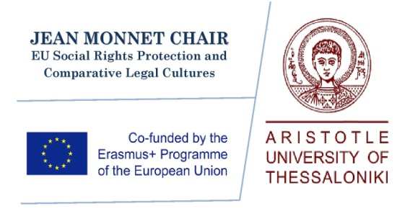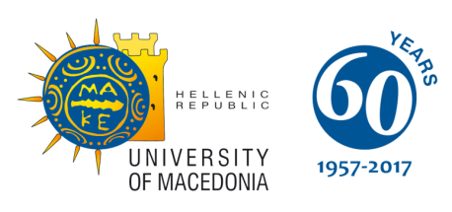

**Jean Monnet Centre of Excellence**

**Research on Crucial Issues of European Integration**

**International Conference**

**Security and Equality in the European Union**

**20 April 2018, 10.30 am**

**Equality and Social Exclusion in the EU**

**Venue**

**19 April 2018, 18.00 pm**

**EU and Transatlantic Defense Challenges**

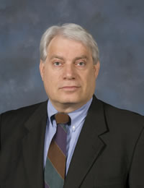

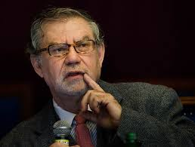



Prof. Dora KOSTAKOPOULOU, Warwick University

Eleni TSETSEKOU, Council of Europe

Prof. Konstantinos TSITSELIKIS, University of Macedonia, Member of the Council of FRA

Assoc. Prof. Ioannis PAPADOPOULOS,

University of Macedonia

Assoc. Prof. Lina PAPADOPOULOU, Aristotle University of Thessaloniki

**Venue: Chamber of Commerce and**

**Industry of Thessaloniki, Tsimiski 29**

Younes EL-GHAZI, Chief Executive Officer, Global Diplomatic Forum, UK

Prof. George FILIS, Deree College of Greece

Alexandros PAPAIOANNOU, Policy Advisor (skype)

Ass. Prof. Fotini BELLOU, University of Macedonia

Ass.Prof. Revecca PEDI, University of Macedonia

B.G. Vittorio Antonio STELLA (Italy), Deputy Chief of Staff Plans Division

**Venue: Conference Room**

**University of Macedonia**

**Key note speaker**

**Joseph H.H. WEILER**

*Joseph Straus Professor of Law*

*New York University, Jean Monnet Chair*

*Co-Director, Jean Monnet Center for International*

*and Regional Economic Law and Justice*

**Key note speaker**

**Stephen BLANK (skype)**

*Senior Fellow*

*at the Foreign Policy Council*

*in Washington, DC*